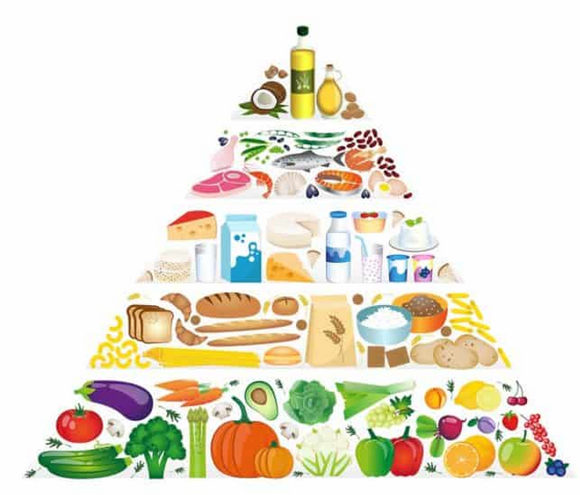

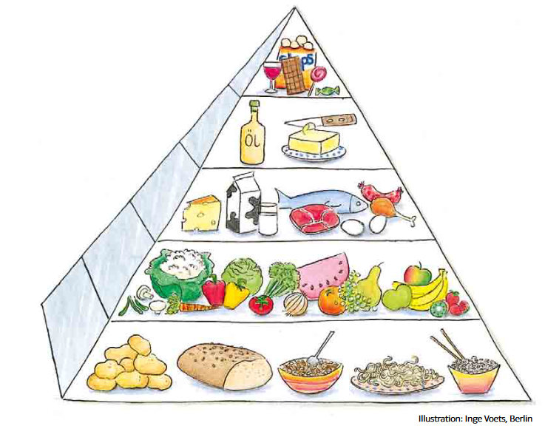

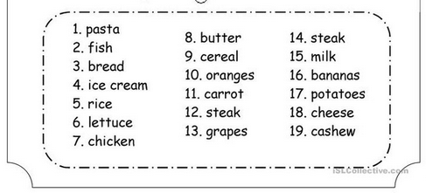

**MY BREAKFAST**

We often hear that breakfast is the most important meal of the day. The Fountain Valley High School cafeteria features posters encouraging students to eat breakfast. But is there truth to this emphasis on breakfast?

One of the biggest advantages to eating breakfast for students is that it [improves concentration](https://pubmed.ncbi.nlm.nih.gov/18948652/). [Studies have shown](https://www.independent.co.uk/news/education/education-news/breakfast-school-gcse-grades-children-austerity-leeds-university-a9209131.html) that children who rarely eat breakfast on school days more often score lower on exams compared to those who do eat breakfast. These effects go beyond students, another [study found that employees with poor health habits](https://www.businesswire.com/news/home/20120806006042/en/Poor-Employee-Health-Habits-Drive-Lost-Productivity) such as not eating breakfast have lost productivity equivalent to 20,000 American workers. This [equates to students](https://athlosacademies.org/healthy-breakfast-benefits-students/" \l ":~:text=Children%20who%20eat%20breakfast%20at,who%20do%20not%20eat%20breakfast.) doing better on tests, improved cognitive function, and memory.

[Students who do skip breakfast](https://frac.org/wp-content/uploads/breakfastforlearning-1.pdf) are less able to discern between visual images and more likely to make errors. There have also been links to teens experiencing hunger being more likely to be suspended, having difficulty getting along with others, and experiencing behavioral problems.

Breakfast foods such as cereal or toast have important nutrients meaning that [students who do eat breakfast](https://www.hopkinsmedicine.org/johns-hopkins-childrens-center/what-we-treat/specialties/nephrology/programs-centers/obesity-hypertension-clinic/_documents/eating-right-wake-up-benefits-breakfast2.pdf) get more fiber, calcium, vitamins A and C, riboflavin, zinc, and iron in their diets. Also, [these students](https://kidshealth.org/en/parents/breakfast.html" \l ":~:text=Kids%20who%20eat%20breakfast%20are,stomach%20complaints%20related%20to%20hunger.) tend to keep their weight under control, have lower cholesterol levels, and have fewer absences in school. Furthermore, eating breakfast has been shown to improve digestion, improve metabolism, strengthen bones, and promote heart health.

Eating breakfast also [improves mood](https://ketteringhealth.org/communityoutreach/pdf/ask/ask-breakfast.pdf) as people with full stomachs tend to be happier and less cranky. Skipping breakfast could mean feeling tired, restless, and grumpy — ultimately harming one’s social life and productivity.

**Sexta‘s breakfast poll**

Do you eat breakfast? .............. Yes, I eat breakfast because.......................

No, ....................... because........................

What do you eat for breakfast?

* ask your classmates and make an interesteing summary for a project

**Lesson 1: Discussion Questions & Answer sheet:**

Many children start the day without eating breakfast; other children only eat a

quick snack. **What are some of the reasons why a child may not be starting the day**

**with a balanced breakfast?**

• There isn’t enough time in the morning

• They are not hungry when they first wake up

• Their parents have already left for work and can’t make breakfast

• They have a long bus ride to school

• Since parents don’t eat breakfast at home, kids don’t take the time to eat either

• They may not have food at home for breakfast

**What happens when children don’t eat breakfast—or eat a poor breakfast?**

• It is harder for them to pay attention because they are hungry

• They may complain of stomachaches or headaches more often

• They may be irritable and act out

• They do not perform as well on tests or quizzes at school or in other activities

**What can parents and children do to ensure that kids eat breakfast?**

• Get up a half an hour earlier so that the whole family can eat breakfast together

• Prepare backpacks the night before to make more time in the morning to eat

without being rushed

• Bring a healthy snack to eat before school or an activity

• Access the school breakfast program in their individual schools

**What are the benefits of eating breakfast?**

• Well-fed children are better prepared to learn

• Children are less likely to be absent or tardy

• A school breakfast program allows children of all socio-economic backgrounds to

participate, thereby reducing the stigma for children who depend on it

• A school breakfast program assures parents their children are receiving nutrition to

keep them fueled for the day’s lessons and activities

• School meals in general reduce the risk of obesity in children by providing regular,

balanced meals that are low in fat and sugar, and by preventing episodic hunger

and subsequent snacking and overeating